**Full name: Thi Ngoc Anh, Tran**

**Student ID: 9102520232**

**Assignment 1 Report**

**a) Make a k-NN (starting with k=5) and its training/validation/evaluation code to perform multiclass classification over all digits.**

* Please, go to this [Link](https://colab.research.google.com/drive/1e3nMVkJAWJt6PiFWGW7wPgnxHCM6vqJp?usp=sharing)

**b) What are the hyperparameters you can tune?**

* The number of neighbors (k) is considered when voting to make a prediction. I tested the k value from 5 to 20 in my code.

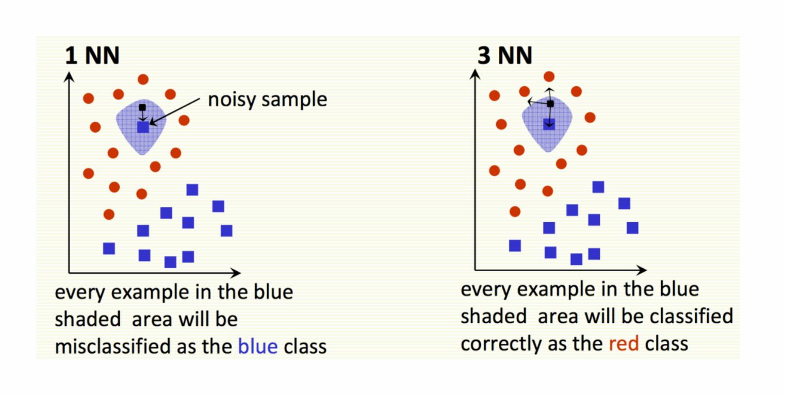

* The type of distance metric (p) is used to compute the distances between two data points. In my assignment, I used 2 common types of distance metrics. There are Manhattan distance (p = 1), and Euclidean distance (p = 2).

**c, Report the performance for each option.**

* With the Euclidean distance (p = 2),

p: 2 k: 5 val_acc: 0.9727

p: 2 k: 6 val_acc: 0.9727

p: 2 k: 7 val_acc: 0.9723

p: 2 k: 8 val_acc: 0.9720

p: 2 k: 9 val_acc: 0.9712

p: 2 k: 10 val_acc: 0.9700

p: 2 k: 11 val_acc: 0.9702

p: 2 k: 12 val_acc: 0.9690

p: 2 k: 13 val_acc: 0.9687

p: 2 k: 14 val_acc: 0.9685

p: 2 k: 15 val_acc: 0.9683

p: 2 k: 16 val_acc: 0.9687

p: 2 k: 17 val_acc: 0.9673

p: 2 k: 18 val_acc: 0.9663

p: 2 k: 19 val_acc: 0.9658

* With the Manhattan distance (p = 1),

p: 1 k: 5 val_acc: 0.9647

p: 1 k: 6 val_acc: 0.9643

p: 1 k: 7 val_acc: 0.9660

p: 1 k: 8 val_acc: 0.9642

p: 1 k: 9 val_acc: 0.9637

p: 1 k: 10 val_acc: 0.9625

p: 1 k: 11 val_acc: 0.9630

p: 1 k: 12 val_acc: 0.9612

p: 1 k: 13 val_acc: 0.9617

p: 1 k: 14 val_acc: 0.9605

p: 1 k: 15 val_acc: 0.9612

p: 1 k: 16 val_acc: 0.9613

p: 1 k: 17 val_acc: 0.9607

p: 1 k: 18 val_acc: 0.9602

p: 1 k: 19 val_acc: 0.9585

**d, What is the final test accuracy?**

* The test accuracy is 0.9666 with the k = 5.